LEVEL-3

VB SCRIPT SYNTAX

- Swap 2 numbers with out temporary variable

Program

Dim a
a=int(inputbox("Enter vaue of a: "))
b=int(inputbox("Enter value of b: "))
a=a+b
b=a-b
a=a-b
print "Value of a is: " &a
print "Value of b is: " &b

Output

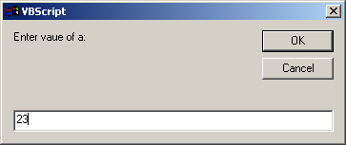

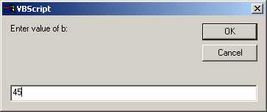

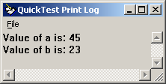

- Print Prime Numbers

Program

Dim a
a=int(inputbox("input enter the number: "))
If a=2 Then
print "Prime"
else
For i=2 to a-1
b=a mod i
If b=0 Then
c=c+1
else
d=d+1
End If
Next
If d<>0 and c=0 Then
print "Prime"
else
print"not prime"
End If
End If

Output

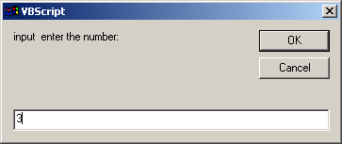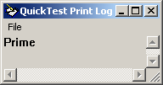

- Sort Array Elements

- Print Element in a collection

Dim a(3)
a(0)=2
a(1)=2
a(2)=2
print a(0)&""&a(1)&""&a(2)

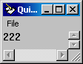

- Find a character in a string

Program
Dim a
a="saravanan"
b=instr(a, "v")
print b

Output

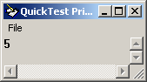

- Print the data in the triangle shape

Dim str
str="saravanan"
strlen=len(str)
For i=strlen to 1 step -1
a=mid(str,i)
print a
Next

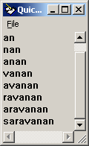

- Replace space with tab in between the words of the string

Program

Dim a
a="sarav asas"
b=chr(9) 'tab value
c=replace(a, " ", b)
print c

Output

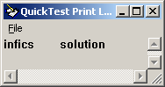

- Convert string to uppercase

Program

Dim a
a="infics solution"
b=ucase(a)
print b

Output

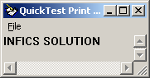

- Returning character specific to ascii value

Program

Dim a
a="s"
b=chr(115)
print b

Output

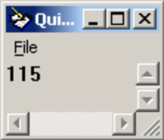

- Display the current time and date

Program

Dim a
a=date
b=time
print "Current Date is: " &a
print "Current Current Time is: " &b

Output

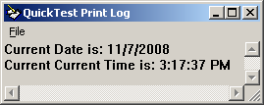

- Difference between two dates

Program

Dim a
a=inputbox("Enter 1st date: ")
b=inputbox("Enter 2nd date: ")
c=datediff("m", a, b)
print c

Output

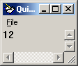

- Replace a word in a string with other word

Program

Dim a
a="infics solution"
b=replace(a,"solution", "ideas")
print b

Output

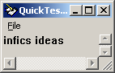

- Converting an array to string

Program

Dim a(3)
a(0)=1
a(1)=2
a(2)=3
b=join(a)
f=typename(a(0))
c=typename(b)
print "The value inside array a(0) is: " &f
print "The output type is: " &c

Output

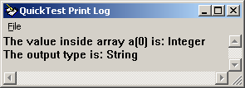

- Create your own class and object

Program

Dim a
systemutil.Run "C:\Program Files\Microsoft Office\Office\EXCEL.EXE", "","",""
set a=createobject("excel.sheet")
a.activesheet.cells(2,3).value="HAi"
a.saveas "F:\test.xls"
Set a=nothing
systemutil.Run "F:\test.xls"

Output

- Read and display the data from a text file

Program

Dim a
Set a=createobject("scripting.filesystemobject")
Set b=a.opentextfile("F:\TEST.txt")
c=b.readall
print c

Output

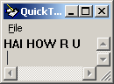

- Find all sub folders in a folder

Program

Dim a
Set a=createobject("scripting.filesystemobject")
set b= a.getfolder("E:\Manual")
set c=b.subfolders
For each d in c
e=d.name
print e
Next

Output

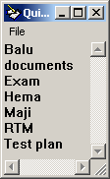

- Remove all empty folder in a folder

Program

Dim a
Set a=createobject("scripting.filesystemobject")
set b= a.getfolder("E:\Test")
set c=b.subfolders
For each d in c
e=d.name
If d.size=0 Then
print "The deleted folder is: " &e
d.delete
End If
Next

Output

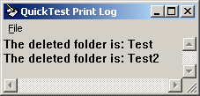

- From a file, print all the lines that start with ERROR

Program

Dim a, b
set a=createobject("scripting.filesystemobject")
set b=a.opentextfile ("C:\Documents and Settings\saravana\Desktop\test.txt")
While b.atendofline=false
c=b.readline
If left(c, 5)="error" Then
print c
End If
Wend

Output

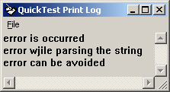

- Replace a word in a string with other word

Program

Dim a
a="infics solution"
b=replace(a,"solution", "ideas")
print b

Output

- Check whether string is in email format

Program

Dim a, b
a=inputbox("Enter email address: ")
b=instr(a, "@")
If ((right(a,4))=".com" or (right(a,4))=".org" or (right(a,3))=".in") and b<>0Then
If (right(a,5))<>"@.com" Then
print "It is an email address"
else
print "It is not an email address"
End If
else
print "It is not an email address"
end if

Input Input

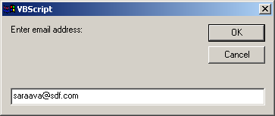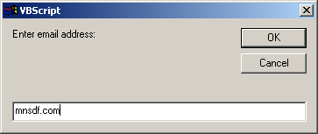

Output Output

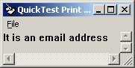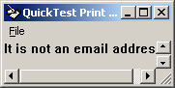

- Check whether string is in date format

Program

Dim a
a=inputbox("Enter date: ")
b=isdate(a)
If b=true Then
print "It is in date format"
else
print "It is not date format"
End If

Input Input

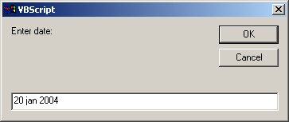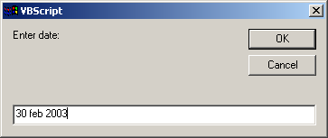

Output Output

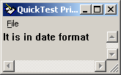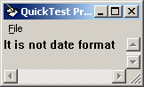

- Place and retrieve the data in the dictionary

Program

Dim a
Set a=createobject("scripting.dictionary")
a.add "a", "alien"
a.add "b", "boss"
a.add "c", "cargo"
b=a.items
For i=0 to a.count-1
print b(i)
Next

Output

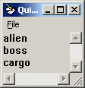

- Retrieve all the cols and rows in a table

Program

Dim a,b
Set a=createobject("ADODB.connection")
Set b=createobject("ADODB.recordset")
a.connectionstring="DSN=emp_details"
a.open
b.open "select * from table1", a
While not b.eof
print b("emp_id")&" "&b("emp_name")
b.movenext
Wend

Output

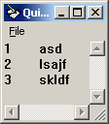

- Retrieve the name of column in the table

Program

Dim a,b
Set a=createobject("ADODB.connection")
Set b=createobject("ADODB.recordset")
a.connectionstring="DSN=thiru;UID=scott;pwd=tiger;"
a.open
b.open "select column_name as a from user_tab_columns where table_name='SAR'",a
While not b.eof
print b("a")
b.movenext
Wend

OUTPUT

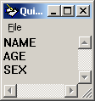

- Print No. of rows in each column

Program

Dim a,b
Set a=createobject("ADODB.connection")
Set b=createobject("ADODB.recordset")
a.connectionstring="DSN=thiru;UID=scott;PWD=tiger;"
a.open
b.open "select count(name) as abc from sar",a
While not b.eof
print "No of rows in table is: " &b("abc")
b.movenext
Wend

Output

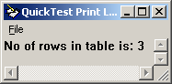

- Print data from oracle database

Dim a,b
Set a=createobject("ADODB.connection")
Set b=createobject("ADODB.recordset")
a.connectionstring="DSN=thiru;UID=scott;PWD=tiger;"
a.open
b.open"select * from SAR", a
While not b.eof
print b ("NAME")&space(3)&b("SEX")
b.movenext
Wend

- Insert a new row into database

Program

Dim a,b
Set a=createobject("ADODB.connection")
Set b=createobject("ADODB.recordset")
a.connectionstring="DSN=thiru;UID=scott;PWD=tiger;"
a.open
b.open "insert into SAR values('y', 54, 'F')",a
b.open"select * from SAR", a
While not b.eof
print b ("NAME")&space(3)&b("SEX")
b.movenext
Wend

Output
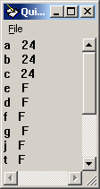

- Update specific field in the database

Program

Dim a,b
Set a=createobject("ADODB.connection")
Set b=createobject("ADODB.recordset")
a.connectionstring="DSN=thiru;UID=scott;PWD=tiger;"
a.open
b.open "update sar set sex='M' where name='b'",a
b.open"select * from SAR", a
While not b.eof
print b ("NAME")&space(3)&b("SEX")
b.movenext
Wend

Output

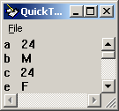

- Write a prg to delete records whose name starts with b

Program

Dim a,b
Set a=createobject("ADODB.connection")
Set b=createobject("ADODB.recordset")
a.connectionstring="DSN=thiru;UID=scott;PWD=tiger;"
a.open
b.open "delete sar where name='b'",a
b.open"select * from SAR", a
While not b.eof
print b ("NAME")&space(3)&b("SEX")
b.movenext
Wend

Output:

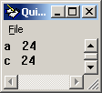

- Write a Script to enter data in login screen

systemutil.Run("C:\Program Files\Mercury Interactive\QuickTest Professional\samples\flight\app\flight4b.exe")
Dialog("Login").WinEdit("Agent Name:").Set "Saravanan"
Dialog("Login").WinEdit("Password:").SetSecure"mercury"
Dialog("Login").WinButton("OK").Click

- Find the x and y coordinates

Window("Flight Reservation").WinButton("FLIGHT").Click
a=Window("Flight Reservation").Dialog("Flights Table").WinButton("OK").GetROProperty("X")
b=Window("Flight Reservation").Dialog("Flights Table").WinButton("OK").GetROProperty("Y")
c=Window("Flight Reservation").Dialog("Flights Table").WinButton("OK").GetROProperty("X")
print a
print b

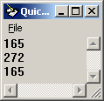

- count items in a list box

Window("Flight Reservation").WinObject("Date of Flight:").Type "121212"
Window("Flight Reservation").WinComboBox("Fly From:").Select "Frankfurt"
Window("Flight Reservation").WinComboBox("Fly To:").Select "London"
Window("Flight Reservation").WinButton("FLIGHT").Click
a=Window("Flight Reservation").Dialog("Flights Table").WinList("From").GetROProperty("items count")
print "Total no. of list is: " &a

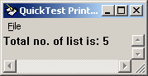

Read items from a list box

a=Window("Flight Reservation").WinComboBox("Fly From:").GetROProperty("items count")
For i=1 to a-1
b=Window("Flight Reservation").WinComboBox("Fly From:").GetItem(i)
print b
Next
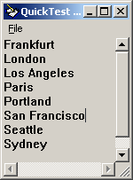

- Read items on the desktop

Dim a
a=Window("Program Manager").WinListView("SysListView32").GetItemsCount()
print "The no. of Items in the Desktop are :"&a
For i =0 to a-1 step 1
c=Window("Program Manager").WinListView("SysListView32").GetItem(i)
print c
Next
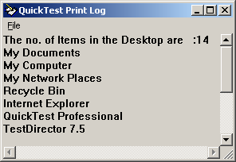
- Capture Desktop Screen shot

SystemUtil.Run "C:\Documents and Settings\saravana\Application Data\Microsoft\Internet Explorer\Quick Launch\Show Desktop.scf","","","open"
window("Program Manager").WinListView("SysListView32").CaptureBitmap "F:\saravanan\test.bmp"
systemutil.Run "F:\saravanan\test.bmp"

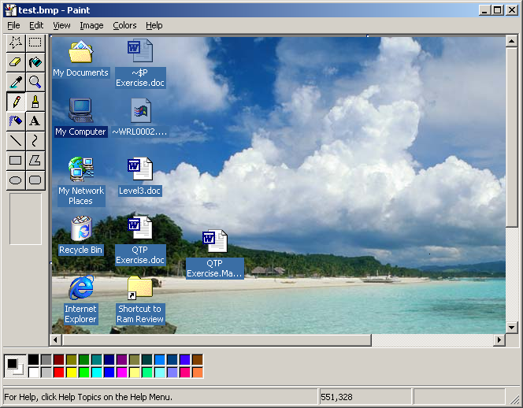

- Read items from a tabbed window

SystemUtil.Run "C:\Documents and Settings\saravana\Application Data\Microsoft\Internet Explorer\Quick Launch\Show Desktop.scf","","","open"
Window("Window").WinListView("SysListView32").Select "My Documents", micRightBtn
Window("Window").WinObject("SHELLDLL_DefView").WinMenu("ContextMenu").Select "Properties"
a=Dialog("My Documents Properties").WinTab("SysTabControl32").GetROProperty("items count")
For i=1 to a-1
b=Dialog("My Documents Properties").WinTab("SysTabControl32").Getitem(i)
print b
Next

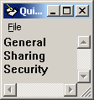

38 Check whether scrollbars exists inside a editor

SystemUtil.Run "notepad","","C:\",""
a=window("Notepad").WinEditor("Edit").GetROProperty("hashscroll")
b=window("Notepad").WinEditor("Edit").GetROProperty("hasvscroll")
print a
print b

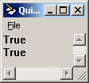

- Check scrollbars in a web page
- Check whether the dialog box is in middle of the window

- Check whether edit box is focused

a=Browser("Cannot find server").Page("Find a Flight: Mercury").WebList("fromPort").GetROProperty("default value")
print a
b=Browser("Cannot find server").Page("Find a Flight: Mercury").WebList("toPort").GetROProperty("default value")
print b

- Check the default selection in list box

a=Browser("Welcome: Mercury Tours").Page("Find a Flight: Mercury").WebList("fromPort").getroproperty("default value")
print a
b=Browser("Welcome: Mercury Tours").Page("Find a Flight: Mercury").WebList("toPort").getroproperty("default value")
print b
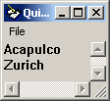

- List all the links in the web Page

Set a = Description.Create()
a("micclass").Value = "Link"
Set b = Browser("Welcome: Mercury Tours").Page("Welcome: Mercury Tours").ChildObjects(a)
c = b.Count()
print "Total links:" &c
print "links are: "
print ""
For i = 0 To c - 1
d=b(i).getroproperty("name")
print d
next

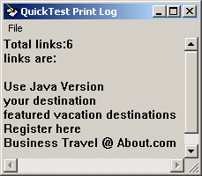

- Print URL name

a= Browser("Welcome: Mercury Tours").Page("Welcome: Mercury Tours").GetROProperty("url")
print a

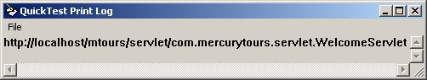

- Check whether web page downloaded completely

a= Browser("Welcome: Mercury Tours").Page("Welcome: Mercury Tours").Object.readyState
print a

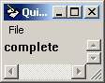

- Check whether the given text displayed on the web page

a=Browser("Welcome: Mercury Tours").Page("Welcome: Mercury Tours").Check (CheckPoint("Welcome: Mercury Tours_3"))
If a Then
print "text is present"
else
print "text is not present"
End If

- Check whether the image contains the tool tip

b=Browser("Welcome: Mercury Tours").Page("Welcome: Mercury Tours").Image("icn_destinations").getroproperty("alt")
If b=empty Then
print "no tool tip"
else
print "tool tip is: " &b
End If

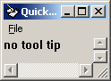

- Invoke application in the browser

invokeapplication "C:\Program Files\Mercury Interactive\QuickTest Professional\samples\flight\app\flight4a.exe"

- Read data from all sheets and all parameters of the file

Datatable.Importsheet "F:\saravanan\test.xls",2, "Global" 'here 2 is sheet name to pickup from excel
Window("Flight Reservation").WinButton("Button").Click
Window("Flight Reservation").Dialog("Open Order").WinCheckBox("Order No.").Set "ON"
Window("Flight Reservation").Dialog("Open Order").WinEdit("Edit").Set datatable.Value("order_no")
Window("Flight Reservation").Dialog("Open Order").WinButton("OK").Click

- Import data to data table from a database

Set a=createobject("ADODB.Connection")
Set b=createobject("ADODB.recordset")
a.Connectionstring="DSN=sara;UID=scott;PWD=tiger;"
a.open
b.open "select * from SAR", a
x=1
While not b.eof
datatable.GetSheet(1).setcurrentrow(x)
x=x+1
DataTable.Value("name")=b(0)
DataTable.Value("age")=b(1)
b.movenext
Wend

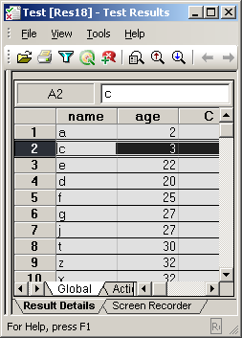

- Read and display data from CSV file

Set a=createobject("scripting.filesystemobject")
set b=a.opentextfile("F:\test.csv")
p=1
While not b.atendofstream
x=b.readline
datatable.GetSheet(1).setcurrentrow(p)
datatable.Value("items",1)=x
p=p+1
wend

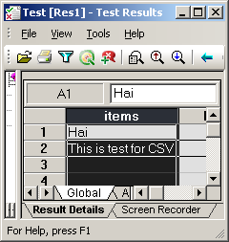

- Display entire data in the web table

a=Browser("Welcome: Mercury Tours").Page("Welcome: Mercury Tours").WebTable("Atlanta to Las Vegas").RowCount
For i=1 to a
b=Browser("Welcome: Mercury Tours").Page("Welcome: Mercury Tours").WebTable("Atlanta to Las Vegas").GetCellData(i,1)
c=Browser("Welcome: Mercury Tours").Page("Welcome: Mercury Tours").WebTable("Atlanta to Las Vegas").GetCellData(i,2)
print b&" "&c
Next

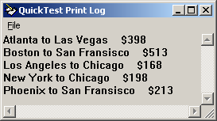

- Find the background color of the object

a=Browser("Welcome: Mercury Tours").Page("Welcome: Mercury Tours").Link("your destination").getroproperty("background color")
print a

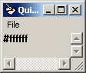

- display screen resolution

a=Window("Program Manager").WinListView("SysListView32").getroproperty("width")
b=Window("Program Manager").WinListView("SysListView32").getroproperty("height")
print "Screen Resolution is: " &a &" X " &b

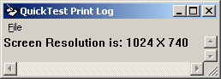

- Write function to compare two bitmaps

a=Browser("Welcome: Mercury Tours").Page("Welcome: Mercury Tours").Image("Register").getroproperty("alt")
b=Browser("Welcome: Mercury Tours").Page("Register: Mercury Tours").Image("support").getroproperty("alt")
If a=b Then
print "same"
else
print "not same"
End If

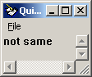

- Add and remove repositories to the action

a="F:\open.tsr"
b="F:\insert.tsr"
c="F:\delete.tsr"

repositoriescollection.Add(a)
repositoriescollection.Add(b)
repositoriescollection.Add(c)

Window("Flight Reservation").WinObject("Date of Flight:").Type "121212"
Window("Flight Reservation").WinComboBox("Fly From:").Select "Frankfurt"
Window("Flight Reservation").WinComboBox("Fly To:").Select "London"
Window("Flight Reservation").WinButton("FLIGHT").Click
Window("Flight Reservation").Dialog("Flights Table").WinButton("OK").Click
Window("Flight Reservation").WinEdit("Name:").Set "saravanan"
Window("Flight Reservation").WinButton("Insert Order").Click

repositoriescollection.Remove(1)

Window("Flight Reservation").Dialog("Open Order").WinCheckBox("Customer Name").Set "ON"
Window("Flight Reservation").Dialog("Open Order").WinEdit("Edit").Set "saravanan"
Window("Flight Reservation").Dialog("Open Order").WinButton("OK").Click
Window("Flight Reservation").Dialog("Open Order").Dialog("Search Results").WinButton("OK").Click

- Load Library files through program
- Enable and Disable Recovery scenarios programmatically

Window("Flight Reservation").Activate
Window("Flight Reservation").WinButton("Button_5").Click
Window("Flight Reservation").WinObject("Date of Flight:").Type "111111"
Window("Flight Reservation").WinComboBox("Fly From:").Select "Fr"
Window("Flight Reservation").WinComboBox("Fly To:").Select "Los Angeles"
Window("Flight Reservation").WinButton("FLIGHT").Click
Window("Flight Reservation").Dialog("Flights Table").WinButton("OK").Click
Window("Flight Reservation").WinEdit("Name:").Set "sdf"
Window("Flight Reservation").WinButton("Insert Order").Click
msgbox "The recovery scenario mech is now:" &" "&Recovery.Enabled

Recovery.enabled=False

Window("Flight Reservation").WinButton("Button_5").Click
Window("Flight Reservation").WinObject("Date of Flight:").Type "111111"
Window("Flight Reservation").WinComboBox("Fly From:").Select "Fr"
Window("Flight Reservation").WinComboBox("Fly To:").Select "Los Angeles"
Window("Flight Reservation").WinButton("FLIGHT").Click
Window("Flight Reservation").Dialog("Flights Table").WinButton("OK").Click
Window("Flight Reservation").WinEdit("Name:").Set "sdf"
Window("Flight Reservation").WinButton("Insert Order").Click

- Report Results status to Results file

reporter.ReportEvent 4,"Insert","This is testing the test report"

- Write your own standard checkpoint

a=Window("Flight Reservation").WinButton("Insert Order").Check (CheckPoint("Insert Order"))
print a

- Check whether there is a memory leak in the process
- Close all the dialogs open on a window

s=Window("Flight Reservation").GetROProperty("hwnd")
window("hwnd:="&s).close

- Read menu names and items

Window("Flight Reservation").Activate
GetNamesRec "", Window("Flight Reservation").WinMenu("Menu")
Function GetNamesRec(itemPath, menuObj)
ret = 0
lbl = menuObj.GetItemProperty(itemPath, "Label")
print lbl
Reporter.ReportEvent 0, itemPath & " label", lbl
ret = menuObj.GetItemProperty(itemPath, "HasSubMenu")
If ret Then
cnt = menuObj.GetItemProperty(itemPath, "SubMenuCount")
Reporter.ReportEvent 0, itemPath & " sub-menu items", cnt
For n = 1 To cnt
Path = menuObj.BuildMenuPath(itemPath, n)
GetNamesRec Path, menuObj
Next
print " "
End If
End Function

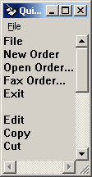

- Check whether a check button is selected or not

a=Window("Flight Reservation").Dialog("Open Order").WinCheckBox("Customer Name").GetROProperty("checked")
b=Window("Flight Reservation").Dialog("Open Order").WinCheckBox("Flight date").GetROProperty("checked")
print "Customer name checkbox: " &a
print "Flight date checkbox: " &b

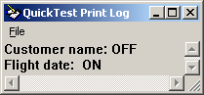

- Check whether we can select multiple items in the combo box
- Check whether edit box allows exactly 15 characters

a=Browser("Welcome: Mercury Tours").Page("Register: Mercury Tours").WebEdit("userName").getroproperty("max length")
If a=15 Then
print "Edit box allows exactly 15 characters"
else
print "Edit box not allows exactly 15 characters"
End If

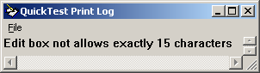

- Check whether items in the page are aligned properly
- Find which add-ins are loaded.

Dim a
Set a=createobject("Quicktest.application")
b=a.getassociatedaddinsfortest("C:\Documents and Settings\saravana\Desktop\test19")
print "Addins enabled in that test are:"
For each c in b
print c
Next

TO FIND ADD-IN FOR CURRENT TEST

Dim a
Set a=createobject("Quicktest.application")
b=a.test.getassociatedaddins()
print "Addins enabled in current test are:"
For each c in b
print c
Next

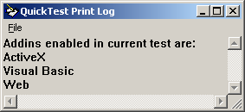

- Check whether a window is in minimized or maximized

a=window("Flight Reservation").GetROProperty("minimizable")
b=window("Flight Reservation").GetROProperty("maximizable")
If a=true Then
print "FR can be minimised"
else
print "FR cannot be minimised"
End If
If b=true Then
print "FR can be maximised"
else
print "FR cannot be maximised"
End If

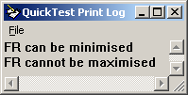

- Check window resizable
- Check whether logo displayed is correct?
- Read all items in a tree

a=Window("My Computer_2").WinTreeView("SysTreeView32").GetItemsCount
For i=1 to a-1
b=Window("My Computer_2").WinTreeView("SysTreeView32").GetItem(i)
print b
Next

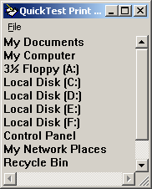

- Read elements in the XML file
- Find font type and size

a=Browser("Welcome: Mercury Tours").Page("Welcome: Mercury Tours").Link("Business Travel @ About.com").GetROProperty("font")
print a

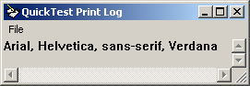

- Check Marquee
- Check whether selected tab is having different appearance?
- Check whether a link contains image to its left side.
- Check whether stock prices are updating an hourly basis
- Modify Mandatory and Assistive properties programmatically
- Configure Run options programmatically
- Define test results location through program
- Read and Update data from environmental variable
- Configure maximum timeout value for web page to load
- Clear the cache in the webpage
- Instruct Quicktest to Capture Movie Segments of Each Error and Warning

- Print arm’s strong number between 1 to 1000

Program

Dim a
For i=1 to 1000
If len(i)=3 Then
If (mid(i,1,1))^3+(mid(i,2,1))^3+(mid(i,3,1))^3=i Then
print I

End If
end if
If len(i)=4 Then
If (mid(i,1,1))^3+(mid(i,2,1))^3+(mid(i,3,1))^3+(mid(i,4,1))^3=i Then
print i
End If
End If
Next

Output

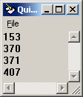

- Find whether the given string is Palindrome or not.

Program

Dim a
a=inputbox("Enter the string to check Palindrome: ")
If strreverse(a)=a Then
print "The string is palindrome"
else
print "The string is not palindrome"
End If

Input Input

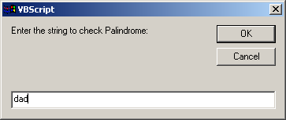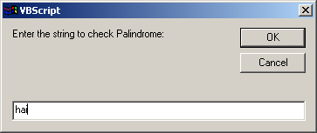

Output Output

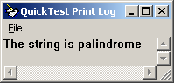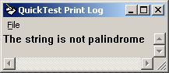

- Write a program to reverse a string

Program

Dim a
a=inputbox("Enter the string: ")
b=strreverse(a)
print b

Output

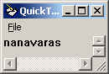

- Write a program to print the numbers divisible by 3 and 5

Program

Dim a
a=int(inputbox("enter the number: "))
print "The numbers divisible by 3 and 5 are: "
For i=1 to a
If (i mod 3)=0 and (i mod 5)=0 Then
print i
End If
Next

Input Output

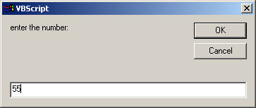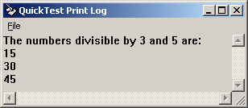

- Write a program to print the numbers divisible by 7

Program

Dim a
a=int(inputbox("enter the number: "))
print "The numbers divisible by 7 are: "
For i=1 to a
If (i mod 7)=0 Then
print i
End If

Next

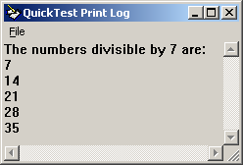

- Write a program to print the list of even nos

Dim a
a=int(inputbox("enter the number: "))
print "The list of even nos below " &a&" are:"
For i=1 to a
If (i mod 2)=0 Then
print i
End If
Next
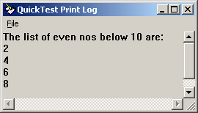

- Write a program to print the list of odd nos

Dim a
a=int(inputbox("enter the number: "))
print "The list of even nos below " &a&" are:"
For i=1 to a
If (i mod 2)<>0 Then
print i
End If
Next

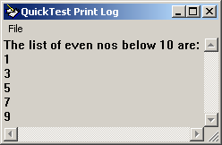

- Find the no. of characters in the string

Program

Dim a
a=inputbox("enter the string: ")
b=len(a)
print "Length of string is: " &b

I/p—Saravanan

Output

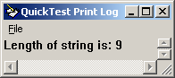

- Write a prg to count only the alphabets

Program

Dim a

a=inputbox("enter the string: ")

b=len(a)

cou=0

For i=1 to b

If asc(mid(a,i,1))>=65 and asc(mid(a,i,1))<=90 or asc(mid(a,i,1))>=97 and asc(mid(a,i,1))<=122Then

cou=cou+1

end if

Next

print "Total alphabets in the string is: " &cou

Output

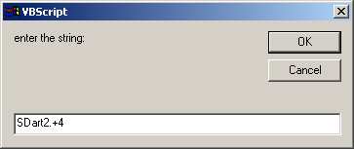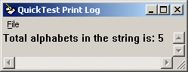

- Check the given no. is greater than 100 or not

Program

Dim a
a=inputbox("enter the number: ")
If a>100 then
print "Given no. is greater than 100"
else if a=100 then
print "Given no. is equal to 100"
else
print "Given no. is less than 100"
end if
end if

Output

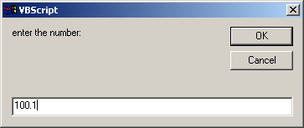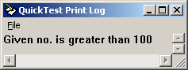

- Find the greatest between the 2 nos.

Program

Dim a
a=int(inputbox("enter the 1st no. "))
b=int(inputbox("enter the 2nd no. "))
If a>b Then
print a &" is greater"
else
print b &" is greater"
End If

- Find the greatest among the 3 nos.

Program

Dim a
a=int(inputbox("enter the 1st no. "))
b=int(inputbox("enter the 2nd no. "))
c=int(inputbox("enter the 3rd no. "))
If a>b and a>c Then
print a &" is greater"
else if b>c then
print b&" is greater"
else
print c &" is greater"
End If
End if

- Fibonacci series

Program

Dim a
n=int(inputbox("enter the no: "))
b=0
c=1
While a<n
a=b+c
b=c
c=a
If a<n Then
print a
End If
wend

Output

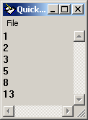
- Compare 2 string and find both r same or not

Dim a
a=inputbox("enter the 1st string: ")
b=inputbox("enter the 2nd string: ")
If strcomp(a,b)=0 Then
print "Both are equal"
else
print "Both are not equal"
End If

- Write a program to add two matrix.

Dim a(2,2),b(2,2),c(2,2)
For i=0 to 1
For j=0 to 1
a(i,j)=int(inputbox("Enter the numbers:"))
b(i,j)=int(inputbox("Enter the numbers:"))
Next
Next

For i=0 to 1
For j=0 to 1
c(i,j)=a(i,j)+b(i,j)
print c(i,j)
Next
Next

- Write a program to subtract two matrix.

Dim a(2,2),b(2,2),c(2,2)
For i=0 to 1
For j=0 to 1
a(i,j)=int(inputbox("Enter the numbers:"))
b(i,j)=int(inputbox("Enter the numbers:"))
Next
Next

For i=0 to 1
For j=0 to 1
c(i,j)=a(i,j)-b(i,j)
print c(i,j)
Next
Next

- Write a program to multiply two matrix
- Input to the Function is “Window Name”. The Function should Check Whether the Window exists or not. If exists activate it or else exit.
Dim a
a=inputbox("Enter screen name: ")
If a="Flight Reservation" Then
If window("Flight Reservation").Exist Then
Window("Flight Reservation").Activate
End If
End If

105 (a.) First take 2 screens, FR and Open Order; In Argument is
“Screen Name”.
(b.) Create 2 shared object repositories (.tsr) for 2 screens that
should be same with “screen name.”
(c.) Based on the screen name, that particular “.tsr” should be
loaded.

i="F:\insert.tsr"
o="F:\open.tsr"
Dim a
a=inputbox("Enter screen name: ")
If a="Insert Order" Then
RepositoriesCollection.add(i)
'Insert Order
Window("Flight Reservation").WinButton("Button").Click
Window("Flight Reservation").WinObject("Date of Flight:").Type "121212"
Window("Flight Reservation").WinComboBox("Fly From:").Select "Frankfurt"
Window("Flight Reservation").WinComboBox("Fly To:").Select "Los Angeles"
Window("Flight Reservation").WinButton("FLIGHT").Click
Window("Flight Reservation").Dialog("Flights Table").WinButton("OK").Click
Window("Flight Reservation").WinEdit("Name:").Set "sdfsdf"
Window("Flight Reservation").WinButton("Insert Order").Click
RepositoriesCollection.removeall()
Window("Flight Reservation").WinButton("Button").Click
Window("Flight Reservation").WinObject("Date of Flight:").Type "121212"
Window("Flight Reservation").WinComboBox("Fly From:").Select "Frankfurt"
Window("Flight Reservation").WinComboBox("Fly To:").Select "Los Angeles"
Window("Flight Reservation").WinButton("FLIGHT").Click
Window("Flight Reservation").Dialog("Flights Table").WinButton("OK").Click
Window("Flight Reservation").WinEdit("Name:").Set "sdfsdf"
Window("Flight Reservation").WinButton("Insert Order").Click
'Open order
else if a="Open Order" Then
RepositoriesCollection.add(o)
Window("Flight Reservation").WinButton("Button_2").Click
Window("Flight Reservation").Dialog("Open Order").WinCheckBox("Order No.").Set "ON"
Window("Flight Reservation").Dialog("Open Order").WinEdit("Edit").Set "10"
Window("Flight Reservation").Dialog("Open Order").WinButton("OK").Click
End if
end if

107 From the popup message, get the text only and display the main
message only.

a=Dialog("Login").Dialog("Flight Reservations").static("Please enter password").GetROProperty("text")
print a

108 From the frame error message, get the text and display only the
main message.

a=Browser("Register: Mercury Tours").Page("Register: Mercury Tours").WebElement("Note: The confirmed password").GetROProperty("innertext")
print a

